13/02/2025
VIET NAM REAL ESTATE MARKET 2024, OUTLOOK FOR 2025
Savills latest market report provides comprehensive insights into Viet Nam's real estate landscape, highlighting industry trends amid the country's strong economic recovery despite global challenges. The report focuses on Ha Noi and Ho Chi Minh City, covering the residential, commercial, and hospitality sectors. It also explores market performance and offers an outlook for 2025.
Macroeconomic Overview
In 2024, despite global economic uncertainty, Viet Nam's economy grew strongly, with GDP rising by 7.1%, exceeding the National Assembly’s target of 6.5-7%
Total registered foreign direct investment (FDI) reached US$38 billion, down 3% year-on-year (YoY), while disbursed FDI increased 9% YoY to US$25 billion. Newly registered FDI fell 8% YoY to US$19.7 billion across 3,375 projects. Manufacturing led with 68%, followed by real estate at 19%.
Newly registered and reopened enterprises reached 233,400, up 7% YoY, while closures rose 15% YoY to 197,900.
Viet Nam welcomed 17.6 million international arrivals, up 40% YoY. Retail sales of goods and services (RSGS) reached US$256 billion, growing by 6%. The consumer price index (CPI) rose 3.6% YoY, while core inflation was 2.7%.
Residential Real Estate
Apartment
In Ha Noi, the apartment sector saw its highest launches since 2020. New supply surged in Q4/2024, with 12,972 units introduced, representing a 146% quarter-on-quarter (QoQ) and 351% YoY increase. Primary stock reached 16,629 units, up by 58% QoQ and 40% YoY. In 2024, new supply totalled 24,996 units, the highest level in five years.
Sales activity in Q4/2024 was robust, with 13,401 units sold, marking a 96% QoQ and 340% YoY increase. New supply accounted for 83% of total sales and achieved an 85% absorption rate, benefiting from clear legal status and reputable developers. Primary asking prices averaged VND 75 million/m2 net sellable area (NSA), up by 9% QoQ and 29% YoY.
Supply shortages are easing; however, prices remain elevated, reflecting the market’s continued strong demand. Residential demand is primarily driven by local buyers, with long-term demand supported by positive net migration, and increasing urbanisation.
In 2025, there will be new supply of 25,200 units. Grade B will remain the largest contributing 88% of future supply, with mega projects comprising 70%. From 2026 onwards, approximately 70,000 units from 91 projects are anticipated, with Dong Anh, Hoai Duc, and Hoang Mai delivering 52% share.
In HCMC, primary stock reached over 6,500 units in Q4/2024, marking a 35% increase QoQ but a 13% decline YoY. In 2024, primary stock improved by 10% YoY to nearly 11,900 units.
Sales of over 2,700 units in Q4/2024 rose by 43% QoQ but were 10% lower YoY. Average prices reached VND 91 million/m2 NSA, increasing by 36% QoQ and 33% YoY due to high-priced new supply and price hikes in existing projects.
The lack of affordable housing options led budget conscious buyers to neighbouring provinces such as Binh Duong, Dong Nai, and Long An. This shift in demand fuelled significant growth in the Binh Duong apartment market, where sales surged by over 200% YoY.
By 2027, about 46,000 units are anticipated from 69 projects in HCMC. Thu Duc City is projected to deliver 52% of the future supply, with Binh Tan contributing 11% and District 7 providing 10%.
Apartment Market Performance in Ha Noi | Apartment Market Performance in HCMC
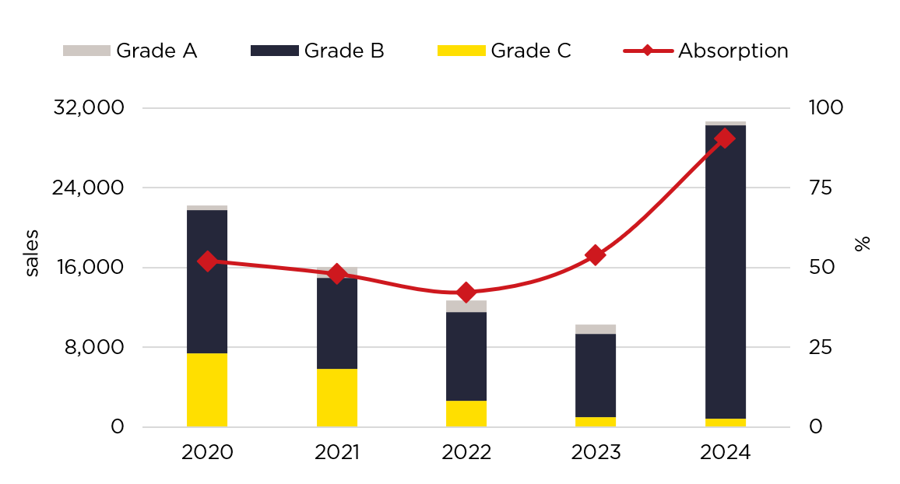 | 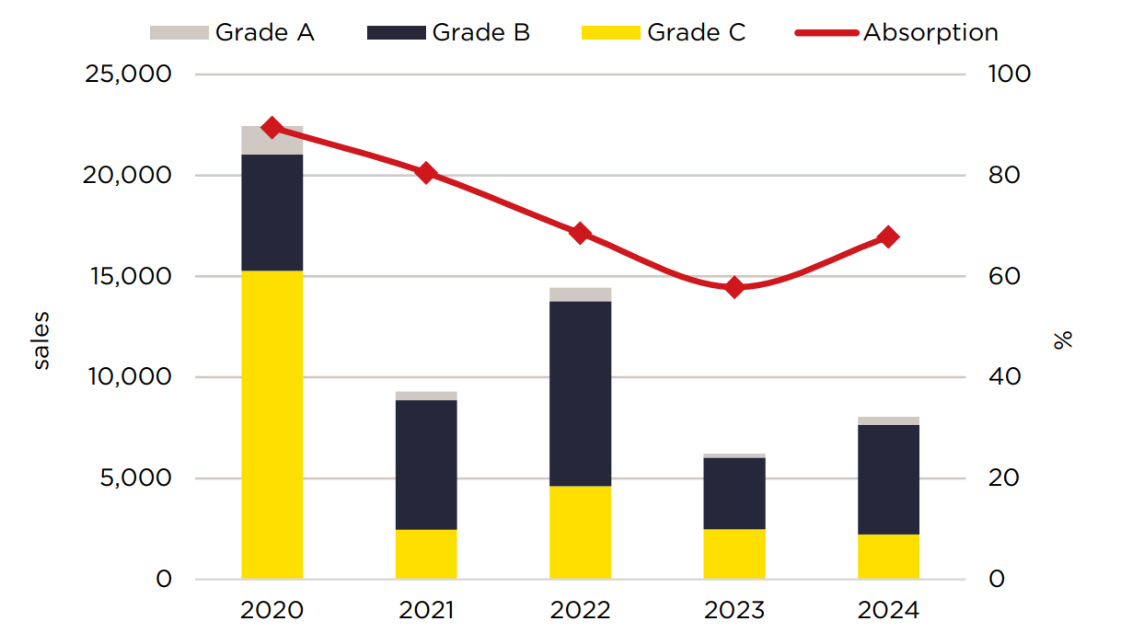
Villa/Townhouse
The villa/townhouse market has shown improved performance compared to the previous period.
In Q4/2024, 4,655 new dwellings were launched from 11 projects in Ha Noi. Primary stock reached 5,002 dwellings across 18 projects, reflecting a sevenfold increase QoQ and YoY. Sales surged sharply in Q4/2024, reaching 3,317 dwellings, 10 times higher QoQ and 52 times higher YoY. Quarterly absorption jumped by 18 ppts QoQ to 66%.
In 2024, new supply in HCMC was limited to 197 units from two projects. Primary stock declined by 2% YoY to 970 dwellings. Properties priced above VND 30 billion/dwelling remained the majority, holding a 74% share. In Q4/2024, sales plummeted by 65% QoQ and 6% YoY. Q4 primary prices increased by 20% QoQ but declined 10% YoY to VND 330 million/m2 LA.
High-end products will continue to dominate HCMC due to land constraints and rising input costs, while affordable supply expands in nearby provinces, supported by improved infrastructure.
In 2025, over 700 dwellings will launch, with 55% from existing project phases. Products priced above VND 20 billion will make up 70%.

Commercial Real Estate
Office
By the end of 2024, Ha Noi’s total office stock reached 2.34 million m2 NLA across 192 projects, marking a 9% QoQ and 10% YoY increase. Meanwhile, in HCMC, 133,000 m2 NLA from 11 new projects was introduced. Non-CBD areas accounted for 65% of new supply, with eight projects reinforcing the shift away from the CBD.
With new supply entering the market, Ha Noi’s occupancy dropped by 5 ppts QoQ and YoY to 82%. Quarterly take-up remained positive across all grades despite the impact of new supply. Grade A has had positive take-up since 2010.
The office market is more in favour of tenants, with a variety of new supply. Tenants benefit from high-quality projects with more rent-free incentives.
Office occupancy in HCMC reached 89% in Q4/2024. Average rent has trended upward over the last ten years to reach VND 816,000/m²/month in 2024, with all grades having an average growth of 2-3% p.a.
ICT tenants and healthcare and medicine tenants led office leasing demand in Ha Noi. Similarly, in HCMC, a Savills survey of 2024 deals showed that the ICT sector overtook surpassed finance, insurance, and real estate (FIRE) as the largest occupier.
Retail
In Ha Noi, stock was stable quarter-on-quarter (QoQ) and rose by 2% year-on-year (YoY) with three new retail podiums: Heritage West Lake, Taisei Square, and Grand Terra.
Gross ground floor rents increased by 2% QoQ and 5% YoY. In the CBD, rents surged by 33% QoQ and 40% YoY, reaching VND 4.5 million/m2/month. Occupancy remained stable QoQ but declined by 3 percentage points (ppts) YoY to 85%.
By the end of 2025, the market is set to expand with 140,700 m² of new retail supply from four shopping centres and three retail podiums. Between 2026 and 2027, an additional 174,100 m2 NLA is expected from seven projects.
Hoang Nguyet Minh, Senior Director, Commercial Leasing, Savills Ha Noi, commented: “International retailers continued to expand in Ha Noi, with luxury retail space remaining in high demand due to scarce suitable supply.”
As of Q4/2024, HCMC’s total stock grew 1% quarter-on-quarter (QoQ) and 6% YoY to 1.6 million m2 NLA. New supply was concentrated in non-CBD areas, supported by larger land banks and expanding urban developments. A Savills survey nearly of 600 leasing deals in 2024 indicated that expansion made up 88% of leased space, while new market entries accounted for 12%. F&B tenants led activity, securing nearly one-third of total space, followed by fashion at 24% and entertainment at 17%.
Average ground floor rent was VND 1.4 million/m2/month, showing YoY increases across all areas. Escalation policies and high rentals at new and CBD properties contributed to growth.
With a dynamic consumer base and an expanding high-net-worth population, HCMC continues to attract foreign brands, particularly in the luxury segment.
Retail Market Performance in Ha Noi | Retail Market Performance in HCMC
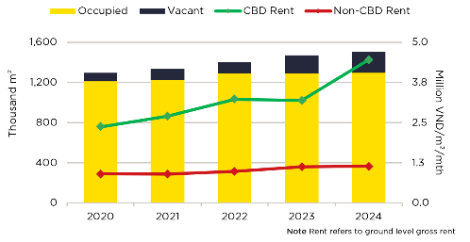 | 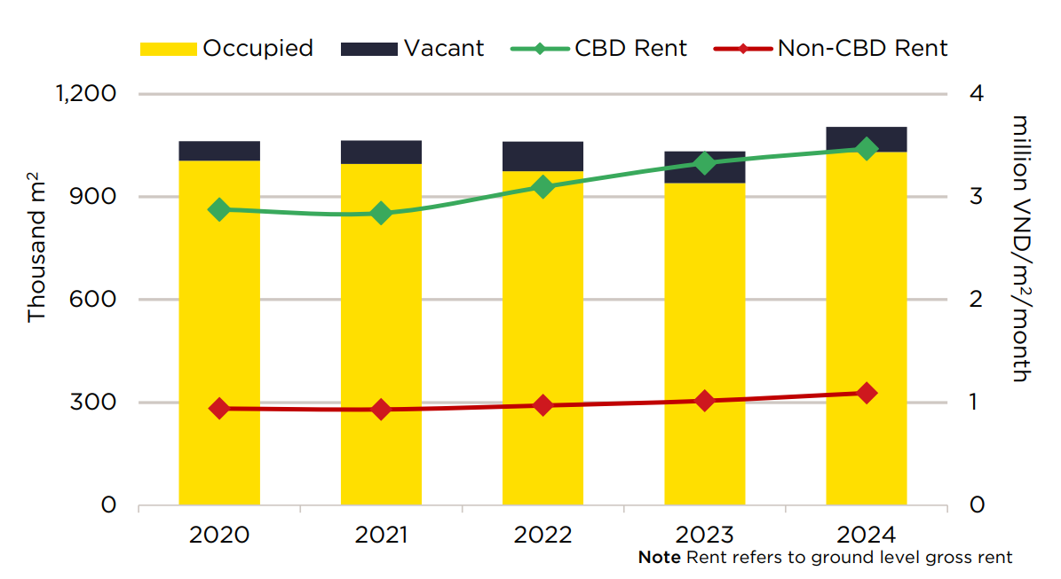
Hotel
The hotel sector is recovering, supported by robust tourism demand.
Ha Noi’s occupancy improved in Q4/2024, reaching 71%, up 3 ppts QoQ and 7 ppts YoY. The average room rate rose by 1% QoQ but fell by 6% YoY. Future supply is set to reshape the market, with 68 projects expected to deliver 12,065 rooms from 2025 onwards. Notable upcoming brands include Hilton, Fusion, Accor, and Four Seasons.
In HCMC, all hotel grades recorded QoQ and YoY improvements, with occupancy rising 10 ppts QoQ and 4 ppts YoY to 71%. ARR increased by 10% QoQ and 6% YoY to VND 2.1 million/room/night.
According to Neil McGregor, Managing Director, Savills Viet Nam: “HCMC is expected to achieve full recovery by 2025, driven by the strong return of international visitors, especially from its key source markets.”
Serviced apartment
In 2024, Viet Nam attracted total registered foreign direct investment (FDI) of US$38.2 billion with 3,375 newly registered projects. Implemented FDI capital stood at US$25.4 billion, marking a 9% YoY increase and the highest level recorded to date.
Matthew Powell, Director, Savills Ha Noi, stated: “The expansion and development of industrial parks in Ha Noi, coupled with strong FDI inflows, are driving significant demand for serviced apartments.” Total stock reached 6,246 units across 64 projects, occupancy improved by 2 ppts QoQ and YoY to 84%. Average rentals rose by 1% QoQ and 2% YoY, with rents in Grade C being the only segment to decrease.
Branded operators will dominate the market, accounting for 87% of the future supply. Notable brands entering the market include The Ascott, Lotte Group, Parkroyal Serviced Suites Ha Noi, Shilla Hotels & Resorts, Hilton, and Hyatt.
In HCMC, Q4/2024’s serviced apartment stock declined by 3% QoQ but remained steady YoY at over 8,000 units. In Q4, rents increased by 2% QoQ and YoY to VND 522,000/m2/month. In addition to rent escalation policies, high year-end demand boosted landlord confidence. Occupancy climbed by 5 ppts QoQ and 1 ppt YoY to 82%, supported by demand from Viet Kieu (overseas Vietnamese), foreign visitors, and business travellers.
Serviced Apartment Market Performance in Ha Noi | Serviced Apartment Market Performance in HCMC
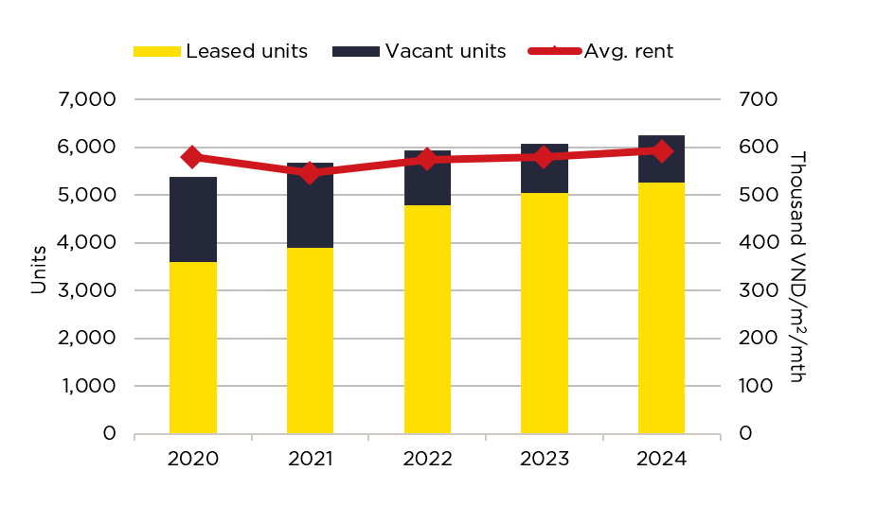 | 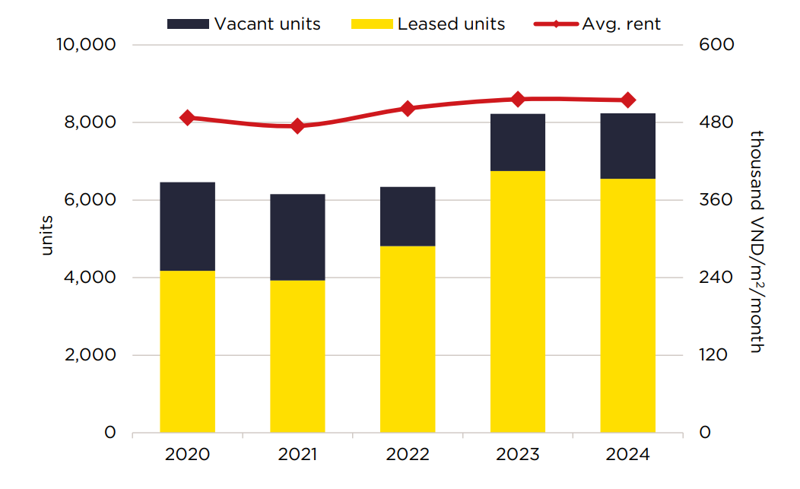
The real estate market performance in Q4/2024 and throughout the year covered residential, commercial, and hospitality sectors, reflecting the industry's transformation in Viet Nam. This also indicates the potential for a more positive market outlook in 2025.

-End-

Any inquiries, please kindly contact:
Vương Thị Khánh Nhung  Trưởng BP truyền thông  Savills TP.HCM  T: +84 909 130 205  E: VThiKhanhNhung@savills.com.vn | Nguyễn Minh Thư  Phụ trách truyền thông  Savills Hà Nội  T: +84 974 701 995  E: NThiMinhThu@savills.com.vn

